MUSI 1700

Lecture 24

Dec 6

* Final will have 10 Questions, you can see the exam template on Brightspace
* Friday Dec 8 class is optional, it will be like office hours
* If you’re writing final in class, you can bring something to write on since desks are bumpy

Q1: scale in alto clef

* know your beaming rules (ex: beaming in 3/4 time is different from beaming in 6/8 time)

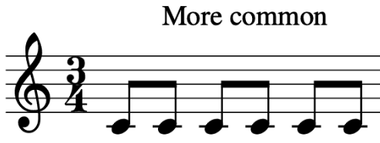 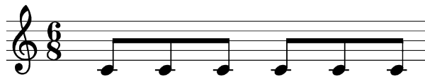

* know the difference between harmonic and melodic minor (harmonic: raised 7 ascending and descending; melodic: raised 6 and 7 ascending, natural minor descending)

Q2: enharmonic notes, scale degrees, figured bass, interval inversions, consonance/dissonance (PC, IC, D), etc…

* 5 types of motion: oblique, stationery, contrary, parallel, similar

Q3,5: SATB (4 voices) and harmonization

Q4: keyboard style

* if given a melody and told to write keyboard style, do not write any notes above the given melody.
* stem direction not being marked, but stem direction is based off of step direction of the note in treble clef is farthest away from the middle note
* Also review cadences!! (PAC, HC, IAC)

Q6,7,8: species counterpoint (2 voices)

* First species: 1-1
* Second species: 2-1, weak beat can be dissonant, introduces embellishing tones (NT, PT, consonant skips), can’t repeat any notes
* We do not need to know 3rd species (4-1)
* Fourth species: 2-1, introduces suspensions, dissonance is ok on strong beat if previous weak beat is consonant

Q9: analysis (review ch 7)

* embellishing tones: PT, NT, INT, pedal tone, retardation, suspension, anticipation (no double neighbours or arpeggiation)
  + Pedal: (usually) bass voice holds non-chord tone, usually over several chords
  + PT, NT can be chromatic (Ch) (note serves as PT or NT but embellishing note is not in the key)
* function symbols (T, D, S) - review in Q10 notes
* Note: In given excerpt, arrows point to non-chord tones
* Bonus: voice exchange

Q10: chord symbols (slash notation, no roman numeral, no figured bass)

* know difference between chord symbol, figured bass, roman numeral, chord function
  + Chord symbols: type of chord without worrying about key, not inverted, written with slash and bass note
  + Figured bass: represents chord’s inversion
  + Roman numeral: represents chord’s root in relation to the key, written without figured bass
  + Chord Function: Tonic, Subdominant, Dominant
    - T: I
    - S: ii and IV
    - D: V and vii